Read the clues and then complete the puzzle.
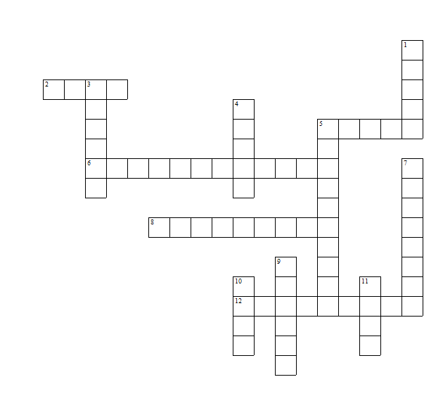
It’s ___________________
They are ______________
Down:

1 Paper used as money ___________
3 A list of all planned expenses and revenues ___________
4 An object that is generally accepted as payment for goods and services ___________
5 A card which you can buy things on credit ___________
7 Fees paid on borrowed assets ___________
9 A piece of paper (usually) that orders a payment of money ___________
10 The redistribution of financial assets, between the lender and the borrower ___________
11 A financial intermediary that accepts deposits ___________

Across:

2 When you owe money ___________
5 A piece of metal that is used for trade ___________
6 The rate of exchange between currencies ___________
8 A place where you withdraw money ___________
12 When withdrawals from a bank account exceed the available balance ___________

Teacher’s answers
